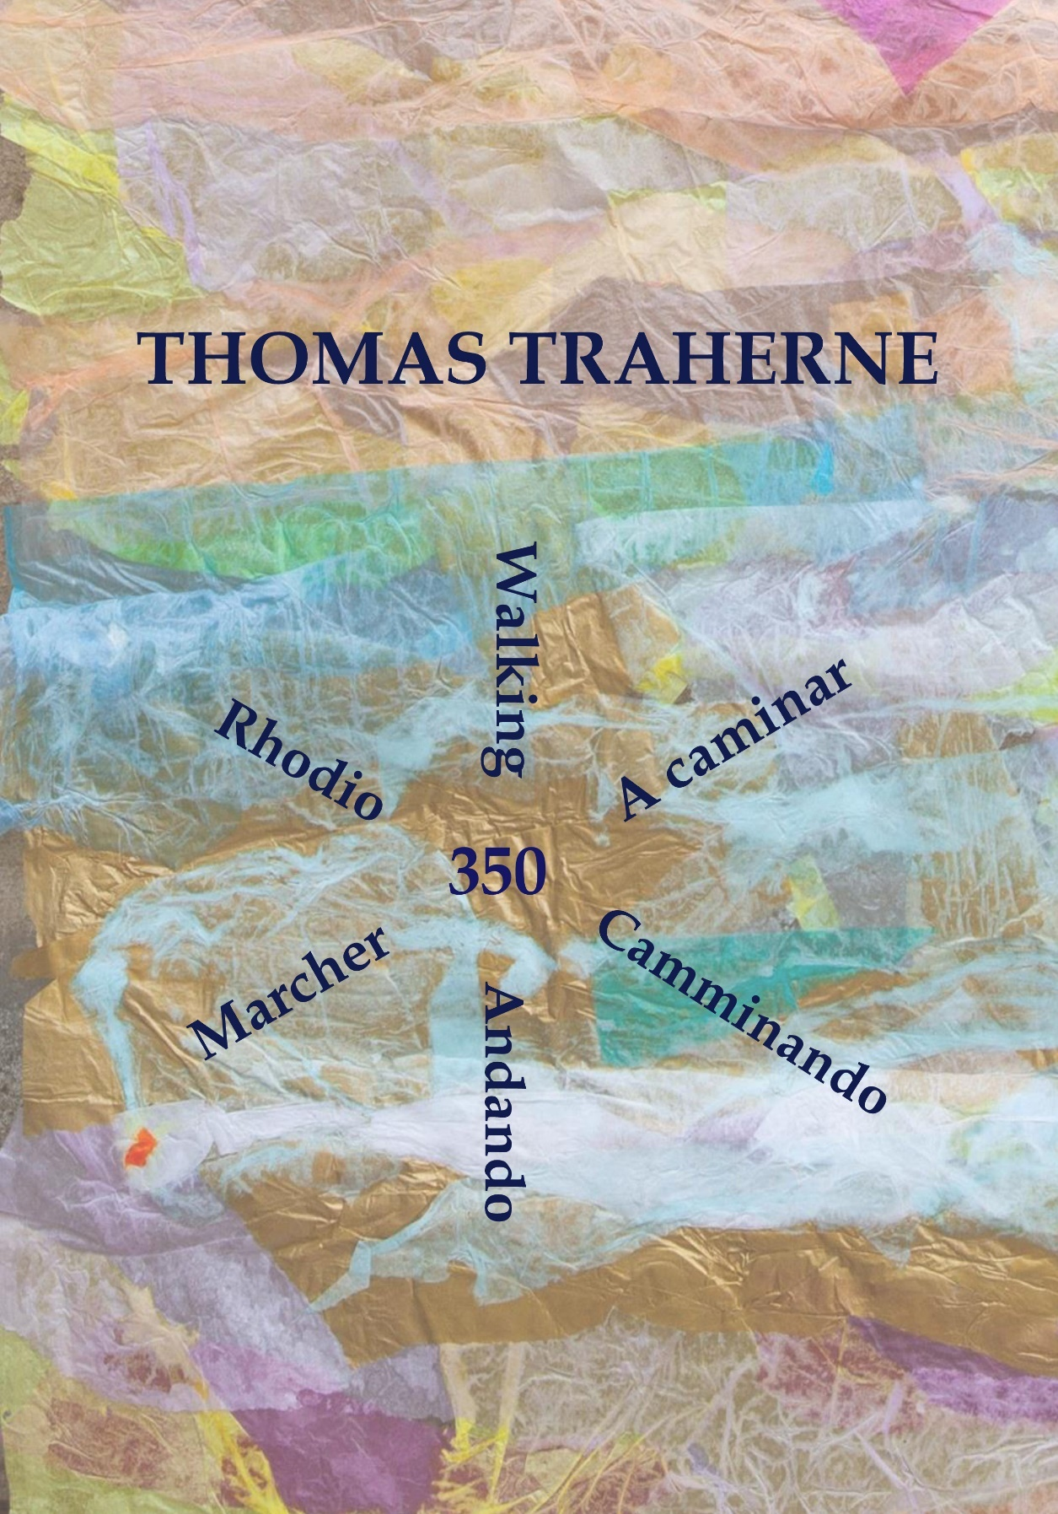

Walking

Thomas Traherne

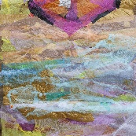

Thomas Traherne 350

Creative Translation Workshop

Oxford, 21 October 2024

The Variety of Languages is a Marvellous Ornament and Beauty to the World.

For either we our selvs, or some other for us must be able to interpret Languages, before we can know the Wisdom and the Beauty of other Nations.

Thomas Traherne

*Commentaries of Heaven*, ‘Babel’

Detail of Traherne- inspired abstract artwork by Brasenose students, with the words 'Dead Puppets may'.

The manuscript of Thomas Traherne’s poem ‘Walking’, showing the first four stanzas. It is in the hand of Traherne’s younger brother, Philip, copied after Thomas’s death from an original which is now lost. Philip was apparently preparing a collection of Thomas’s poems entitled ‘Poems of Felicitie’ for publication, but the project never came to fruition.

(British Library, Burney MS 392)

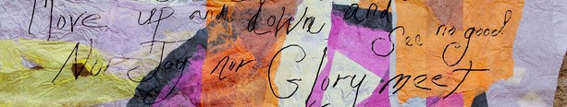

Walking

To *walk* abroad is, not with Eys,

But Thoughts, the Fields to see & prize;

Els may the silent Feet,

Like Logs of Wood,

Mov up & down, & see no Good,

Nor Joy nor Glory meet.

Ev’n Carts & Wheels their place do change,

But cannot see; tho very strange

The Glory that is by:

Dead Puppets may

Mov in the bright & glorious Day,

Yet not behold the Sky.

And are not Men than they more blind,

Who having Eys yet never find

The Bliss in which they mov:

Like Statues dead

They up & down are carried,

Yet neither see nor lov.

To *walk* is by a Thought to go;

To mov in Spirit to & fro;

To mind the Good we see;

To taste the Sweet;

Observing all the things we meet

How choice & rich they be.

To note the Beauty of the Day,

And golden Fields of Corn survey;

Admire each pretty Flow’r

With its sweet Smell;

To prais their Maker, & to tell

The Marks of His Great Pow’r.

To fly abroad like active Bees,

Among the Hedges & the Trees,

To cull the Dew that lies

On evry Blade,

From evry Blossom; till we lade

Our *Minds*, as they their *Thighs*.

Observ those rich & glorious things,

The Rivers, Meadows, Woods, & Springs,

The fructifying Sun;

To note from far

The Rising of each Twinkling Star

For us his Race to run.

A little Child these well perceivs,

Who, tumbling in green Grass and Leavs,

May Rich as Kings be thought:

But there’s a Sight

Which perfect Manhood may delight,

To wch we shall be brought.

While in those pleasant Paths we talk

‘Tis *that* tow’rds wch at last we walk;

For we may by degrees

Wisely proceed

Pleasures of Lov & Prais to heed,

From viewing Herbs & Trees.

The first printed text of ‘Walking’, from Thomas Traherne, *Poems of Felicity*, ed. H. I. Bell (Oxford, 1910). In transferring the manuscript text to print, the textual editor has had to make some of the same decisions as the translator about punctuation, capitalization, and layout.



Opposite: Traherne ‘Walking’ collage, created by students of Brasenose College, Oxford for the Traherne 350 commemoration.

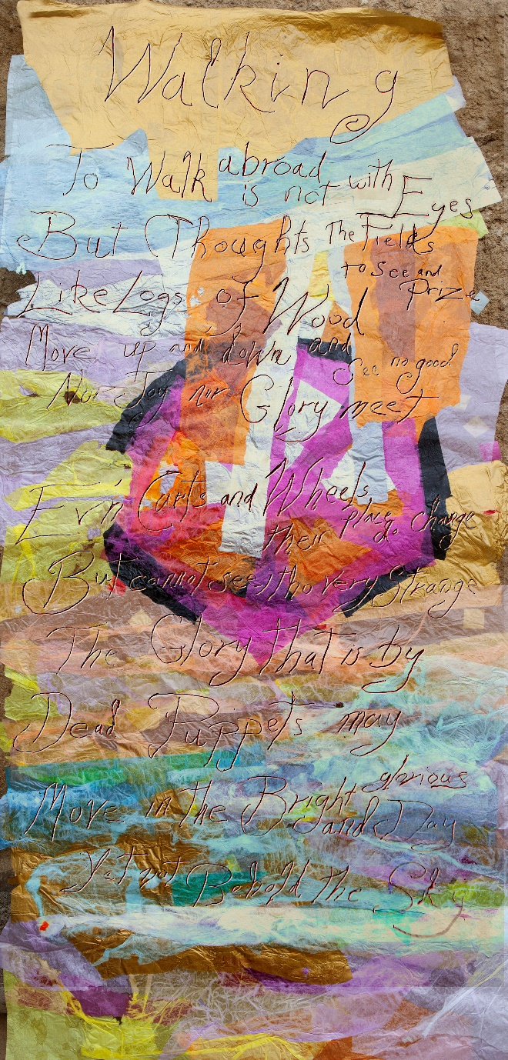

French

Marcher

Il n’est nul besoin de voir, pour marcher à la découverte du monde,

Mais d’esprit, pour saisir le paysage à la ronde;

Sans quoi, les pieds foulant le sol, silencieux,

Sont comme deux bouts de bois,

De bas en haut, ignorant tout de la beauté qui les entoure,

Sans rencontrer ni joie, ni rien de merveilleux.

Comme les chariots et les voitures qui, roulant,

Ne voient rien, étonnamment

Des merveilles qui leur font face:

Ainsi que des marionnettes sans vie

Peuvent avancer dans une journée ensoleillée

Sans lever la tête au ciel, hélas.

Et sont les hommes encore moins capable de voir,

Qui ont des yeux mais ne vont jamais percevoir

La beauté du monde qui les entoure:

Comme des statues sans vie

Portées là et ici,

Sans jamais vraiment voir ou s’émouvoir.

Marcher, c’est aller par l’esprit;

Se mouvoir par la pensée, là et ici;

C’est réfléchir sur la beauté du monde;

Gouter à la douceur du temps;

Observer toutes les choses se présentant

Voir oh combien spéciales et précieuses elles sont.

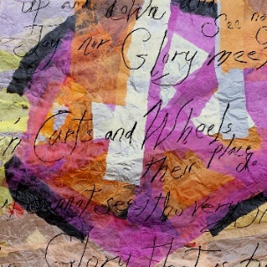

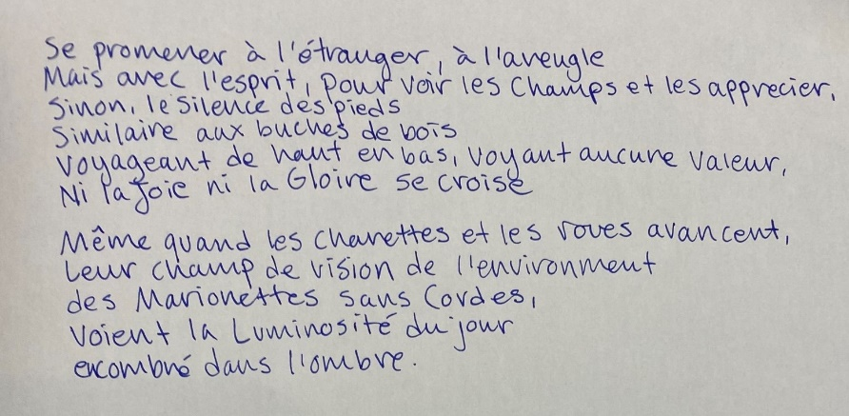

Chinese

**Translation 1: To the Form of New Poetry**

跨界限的不是眼睛，

是思想，識見的寶境；

縱使步步為營，

穩如圓木，

不過徒受上下之苦

難見善與光明。

**Translation 2: To the Form of *Paifu***

余徙異境，不倩瞻視,

稟神智，照妍蚩。

惜慎行之不足，

縱穩如椽，

俯仰枉歷，善不得傳，

樂並華光遁矣。

**Translator’s Note**

The source text has 9 stanzas in iambic meter. Each stanza has 40 syllables with an 8-8-6-4-8-6 structure, following an AABCCB rhyme scheme. I translated the first stanza to the form of New poetry (xinshi, 新詩) and then to the form of Couplet Rhapsody (paifu, 俳賦), a form of Classical Chinese poetry that used to flourish together with the Sywan-yan Poetry (xuanyan shi, 玄言詩, Chinese metaphysical poetry) in the Six Dynasties Period (220–589 C.E.).

My first translation to the form of New Poetry rhymes in Mandarin Chinese and follows the AABCCB scheme in the 8-8-6-4-8-6 structure. My other one to the form of Couplet Rhapsody sounds better in Cantonese, following the AABCCB scheme in a slightly-adjusted 8 (4+4)-6 (3+3)–6-4-8(4+4)–6 structure (according to the Couplet Rhapsody rules).

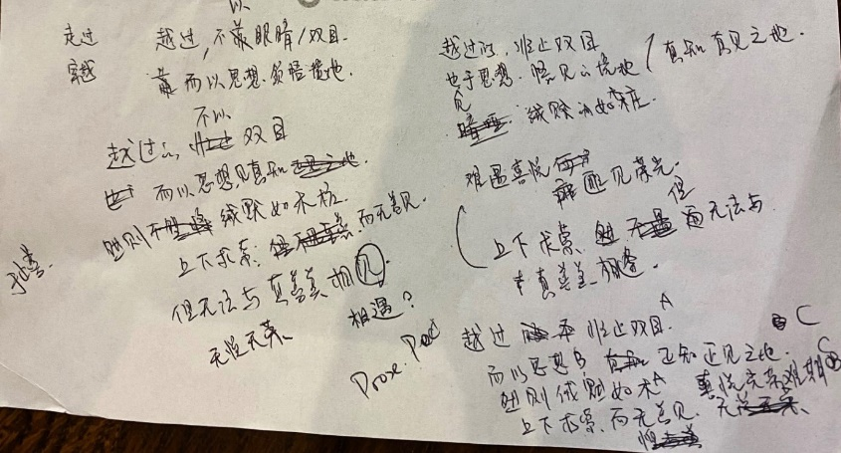

Spanish

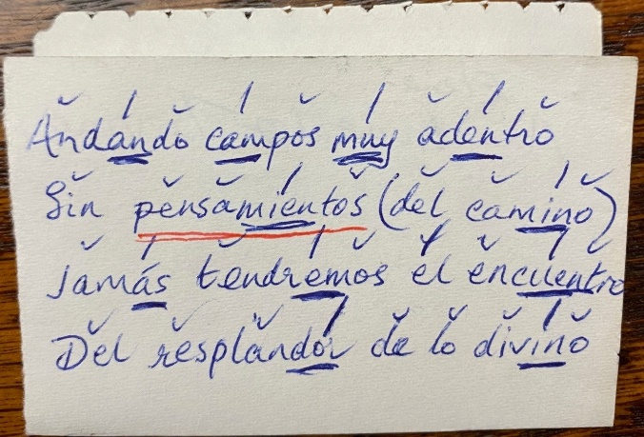

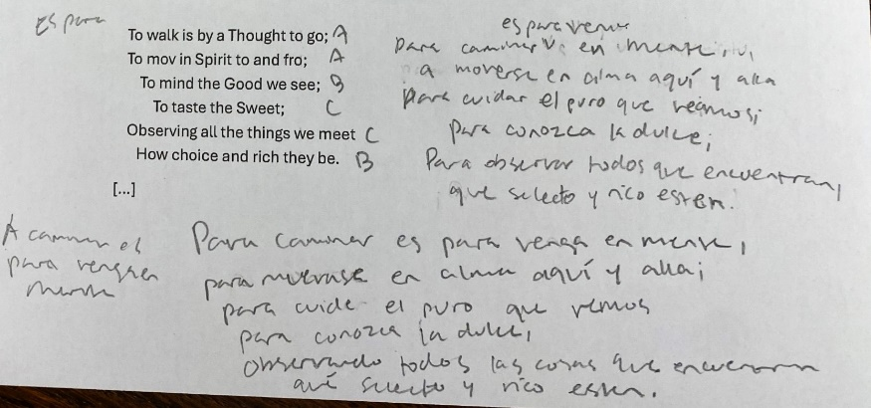

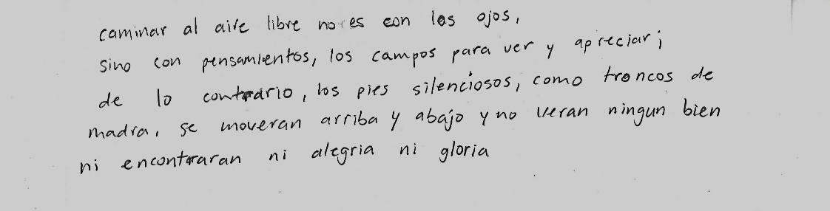

Andando (Walking)

Andar en el extranjero es, no con los ojos,

Pero Pensamientos, los campos a ver y apreciar a todos;

Si no que los pies sin ruido,

Como troncos de madera,

Suben y bajan, y no veen lo bueno afuera,

Ni Alegría ni Gloria se encuentran a pesar de su pedido.

Incluso Carros y Ruedas su lugar si cambia,

Pero no pueden ver; aunque muy extraño sea

La Gloria que está alrededor:

Las marionetas muertas pueden

Moverse en el día brillante y glorioso donde nunca duermen,

Pero sin contemplar ni el cielo ni una flor.

Y no son los hombres mas ciegos que ellos,

Que teniendo ojos, no encuentran nunca lejos

La dicha en que mueven:

Como las estátuas muertas

Ellos arriba y abajo son llevadas

Pero ni ven ni aman como deben.

Andar es ir con el Pensamiento;

Moverse en Espíritu de un lado a otro;

Tener en cuenta lo bueno que estamos viendo;

A probar el dulce que comeremos;

Observando todas las cosas que conocemos

Como opción y ricas están siendo.

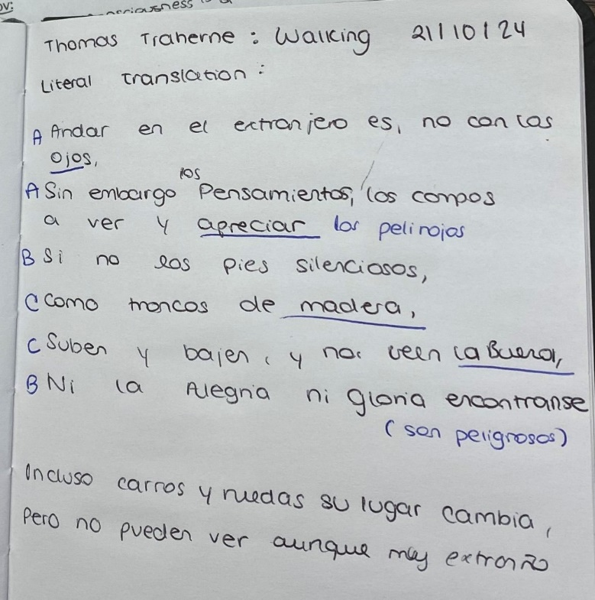

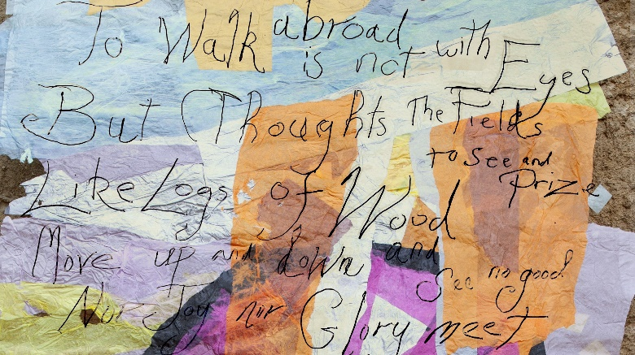

Welsh

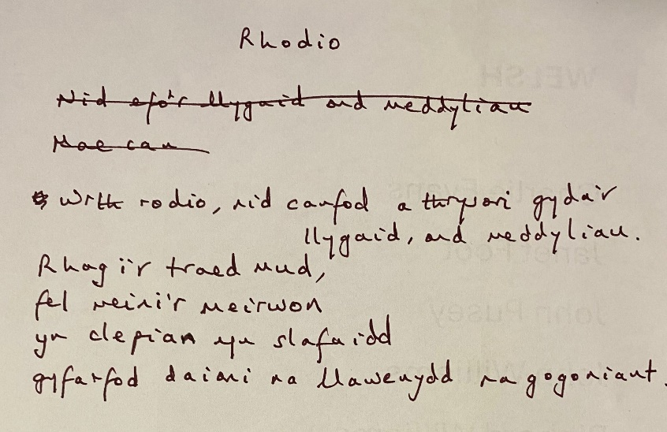

Rhodio

Wrth rodio, nid canfod a thrysori’r caeau gyda’r llygaid ond meddyliau;

Rhag I’r traed mud fel meini’r meirwon

Yn clepian yn slafaidd

Gyfarfod na Daioni, na Llawenydd na Gogoniant.

Mae hyd yn oed cerbydau ac olwynion yn newid lle

Ond yn methu gweld ; er yn rhyfedd iawn

Y Gogoniant sydd gerllaw:

Gall pypedau meirwon symud yn y disglair a gogoneddus Ddydd

Ond methu darganfod y Wybren.

Bengali

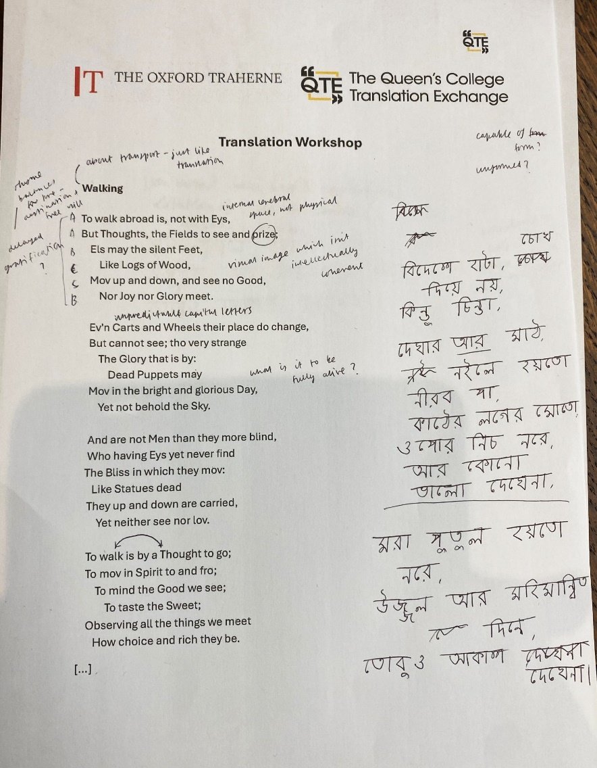

Italian

Camminando

Camminare all’aperto non è questione di occhi,

ma di pensieri che sanno vedere ed apprezzare i campi;

altrimenti i piedi, silenziosi,

come pezzi di legno

andrebbero avanti e indietro senza cogliere nulla di valido,

né incontrare gioia o splendore.

Persino i carri e le ruote cambiano posizione,

eppure non vedono — per quanto sembri strano —

la magnificenza che li circonda;

morte marionette

si muovono nel giorno raggiante e luminoso

senza mai ammirare il cielo.

E non sono forse più ciechi di loro quegli uomini

che, pur avendo occhi, non incontrano mai

la felicità nel mondo in cui si aggirano?

Come statue senza vita

vanno su e giù,

senza mai vedere né amare.

Camminare è procedere con un pensiero;

muoversi nello spirito, avanti e indietro;

accogliere il bene che vediamo,

gustarne la dolcezza;

osservare ogni cosa che incontriamo

e stimarne il valore e la ricchezza.

Notare la bellezza del giorno,

scrutare i campi di grano dorati;

ammirare ogni fiore grazioso

e il suo dolce profumo;

lodare il loro Creatore e riconoscere  
i segni del suo grande potere.

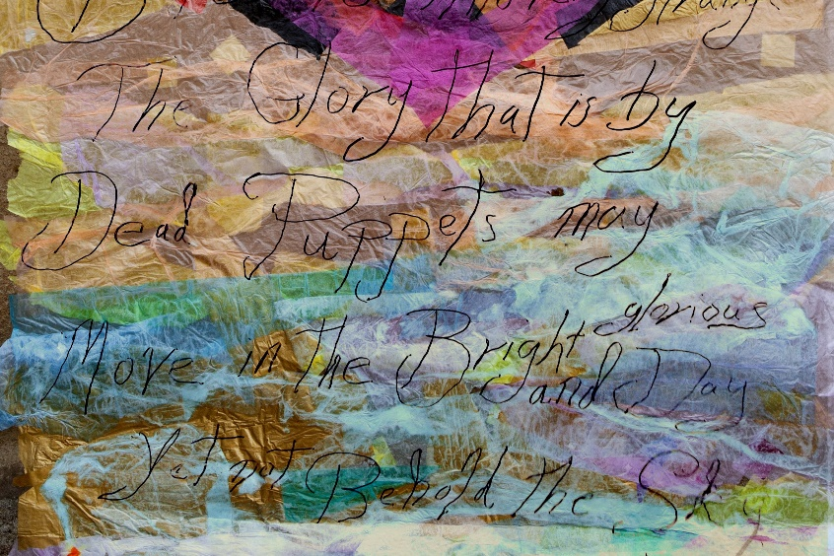

Pashto

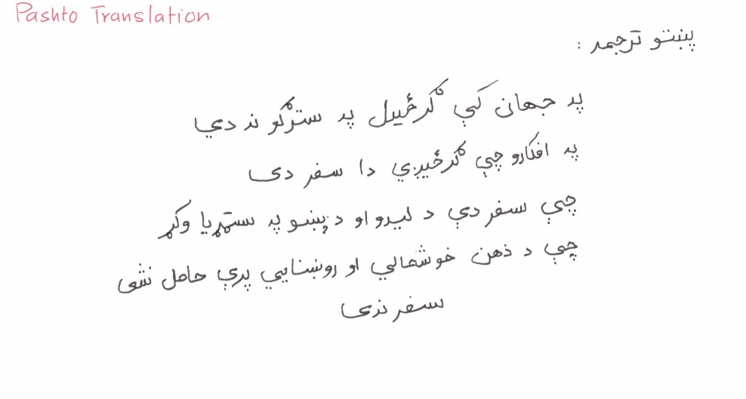

Dari

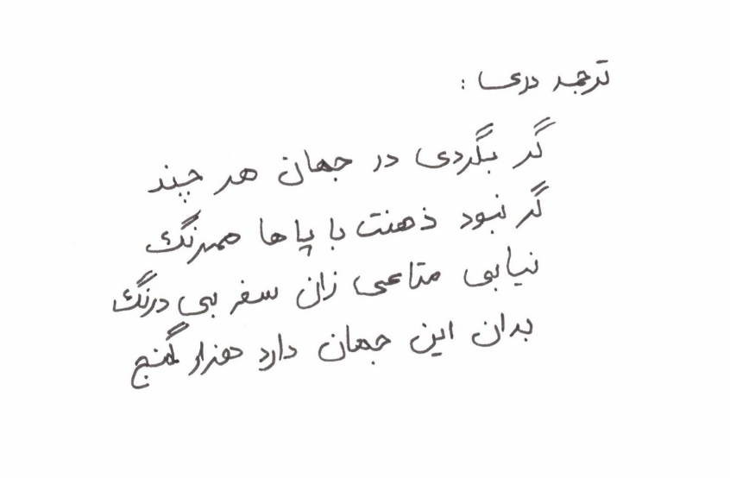

Translator’s note: For the Pashto translation, I used a form of poetry known as Ghazal, which is significant in Pashto culture. The Dari translation follows the regular poetic format.

German

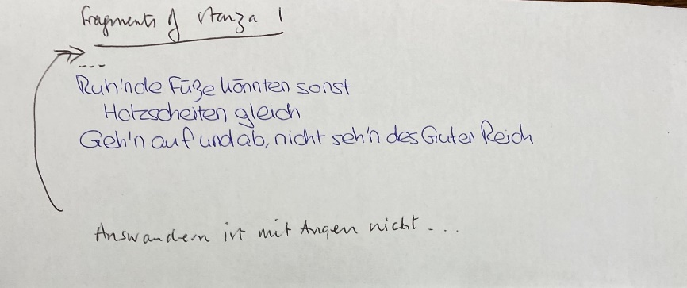



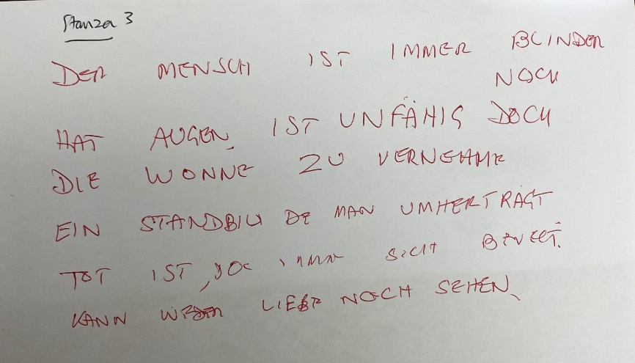

Arabic

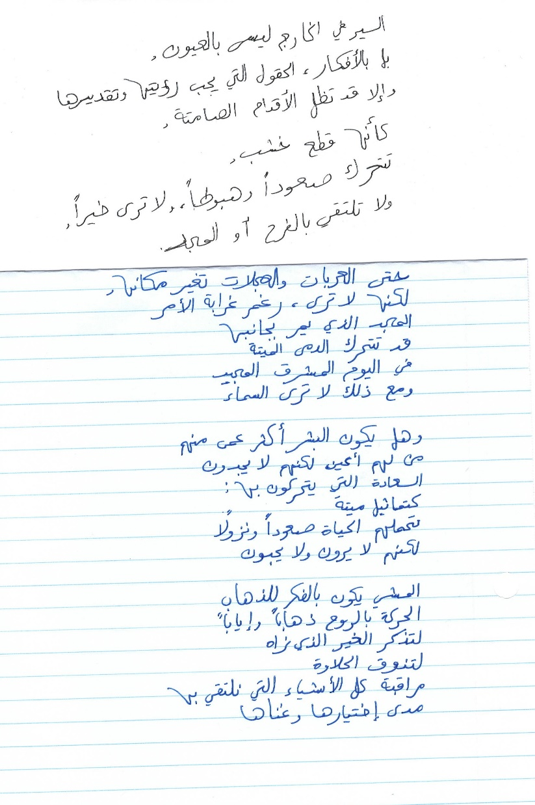

Thomas Traherne

Thomas Traherne was born in Hereford in about 1637, the son of a master shoemaker, and his writings vividly re-create his childhood experiences. He was admitted to Brasenose College, Oxford, in 1653, and in 1657 was presented to the tiny rural living of Credenhill in Herefordshire. Credenhill was the setting for the composition of almost all his extant works, and Traherne remained there until early 1674, when he moved to Teddington, Middlesex, to become a domestic chaplain to Sir Orlando Bridgeman, former Lord Keeper of the Great Seal. He died a few months later, and was buried at Teddington on 10 October 1674.

During his lifetime, Traherne completed for publication only the polemical *Roman Forgeries* (1673) and *Christian Ethicks* (1675), a treatise on virtue. But he is chiefly known today through the dramatic discoveries made during the twentieth century, and still continuing, of his unpublished manuscript writings, which have disclosed him as a writer of great originality and spiritual beauty.

Traherne’s writing is characterized by an intense and radiant vision of felicity, a desire to reconcile opposites, and a belief in the unlimited human potential to reflect the image of God.

His works include poetry, *Centuries of Meditations*, *Select Meditations*, *Commentaries of Heaven*, and the *Kingdom of God*.

The Traherne Creative Translation Workshop formed part of Traherne 350, a week of events held in Oxford, UK, to commemorate the 350th anniversary of the death of the poet and spiritual writer Thomas Traherne (*c*.1637-1674). Traherne 350 was organized by the Oxford Traherne edition in collaboration with Brasenose College, Oxford. The translation workshop was run by Dr Charlotte Ryland of The Queen’s College Translation Exchange, with contributions by Gwyneth Lewis, former National Poet of Wales, and Professor Ana Elena González-Treviño (UNAM-UK and KCL), translator of Traherne’s *Centuries* into Spanish.

The translations were mainly produced collaboratively in the course of the workshop, and are unattributed. Later versions were subsequently submitted by Janet Foot, Megan Jones, Lucy Ladret, Erika Qian Liang, and Erminia Passannanti. Translations have also been contributed by Ahmad Abu El Hawa, Abdul Rahman Daudzai, and Jonathan Machado, students from Dr Cynthia Saenz-Weinand’s literature class at Northern Virginia Community College, where a mirror event was held.

For further information, see: <https://oxfordtraherne.web.ox.ac.uk/>

<https://www.queens.ox.ac.uk/research-at-queens/translation-exchange/>